
Trinka AI User Manual
Comprehensive Onboarding Guide

✓ AI-Powered Grammar and Writing Enhancement
✓ Academic Paraphrasing and Content Generation
✓ AI Content Detection and Proofreading Tools

www.trinka.ai

Prepared for University Faculty and Students

Table of Contents
Table of Contents 2
1. About Trinka AI 3
1.1 Overview 3
1.2 Key Benefits 3
1.3 Purpose of This Guide 3
2. Getting Started 4
2.1 Creating Your Trinka Account 4
2.2 Institutional Access Activation 5
3. Core Features 6
3.1 Trinka Cloud Editor 6
3.1.1 Uploading a File 6
3.1.2 Creating a New File 8
3.2 Paraphraser 10
3.3 Trinka AI Studio 12
3.3.1 AI-Assisted Writing Using /Ask 12
3.3.2 Using AI Prompts on Selected Text 14
3.3.3 Custom AI Tools for Educators and Students 16
3.4 Trinka Browser Plugins 17
4. Key Workflows 18
4.1 Editing with the Cloud Editor 18
4.2 Proofreading a File 21
5. Verifying content authenticity 25
5.1 Generating AI Content Detector Reports 25
6. Additional Information 27
6.1 Language Support 27
6.2 Related Platforms 27
6.3 Feature Usage and Credit Consumption 27
6.4 Resources 28
6.5 Support and Feedback 28

1. About Trinka AI

1.1 Overview
Trinka is an AI-powered writing assistant designed for academic and technical writing. Trinka corrects advanced grammar errors and contextual spelling mistakes by providing writing suggestions in real time. It helps academicians write in a formal, concise, and engaging manner.
In addition to correcting grammatical errors, Trinka allows you to paraphrase text and improve consistency, enabling you to enhance the quality of your writing based on your needs.

1.2 Key Benefits
- Real-time grammar and spelling correction tailored for academic writing
- AI-powered paraphrasing to enhance clarity and fluency
- Proofread File feature for document review with track changes
- AI Studio for Content Generation, Outlining, and Text Transformation
- AI Content Detector reports for verifying content authenticity
- Browser plugins for Chrome, Firefox, and Edge
- Support for multiple languages, including English and Spanish

1.3 Purpose of This Guide
This document is a detailed, step-by-step guide for university members to explore and use the features of Trinka AI. It starts with the registration process and moves on to activating the Trinka Institutional Access plan, making grammar corrections, paraphrasing text, and finally, preparing your document for submission. By following this guide, you can seamlessly use Trinka and take full advantage of its features.

2. Getting Started

2.1 Creating Your Trinka Account
All academicians, students, lecturers, and professors can avail premium access to Trinka AI writing assistant by following the steps below.
Step 1: Go to the Trinka website.
Navigate to https://www.trinka.ai/ in your web browser.
Step 2: Click on Register.
Click on "Register for Free" or "Register" that appears on the web page.

Figure 1: Trinka AI homepage with registration options
Step 3: Register with Your University Email
Use your university domain email (@userdomain) to create an account. This is necessary for enabling your access to the Trinka Institutional Plan.
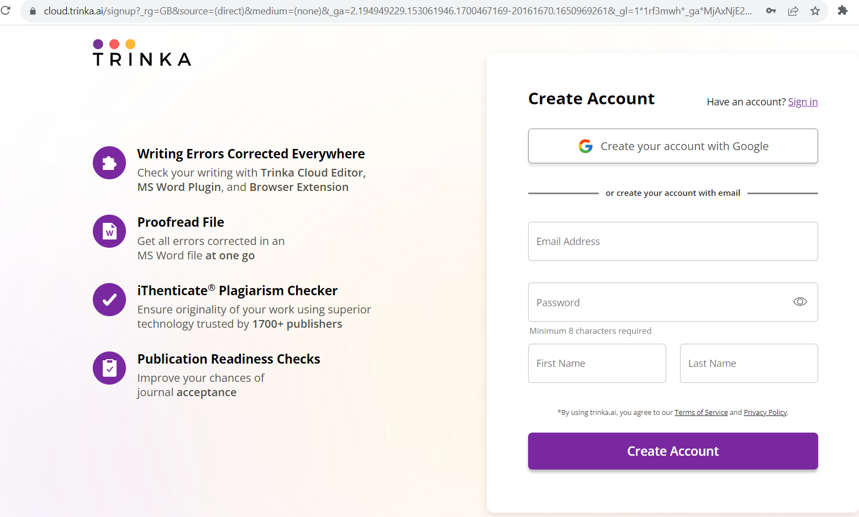
Figure 2: Trinka registration form
Important: Please ensure that you are using email IDs with your university domain, as this is necessary for gaining access to the Trinka Institutional Plan.

2.2 Institutional Access Activation
Once you sign in or sign up with your university email, your account will automatically upgrade to the Institutional Plan. You will see your university logo on the top left of the dashboard, confirming your Institutional Access subscription.
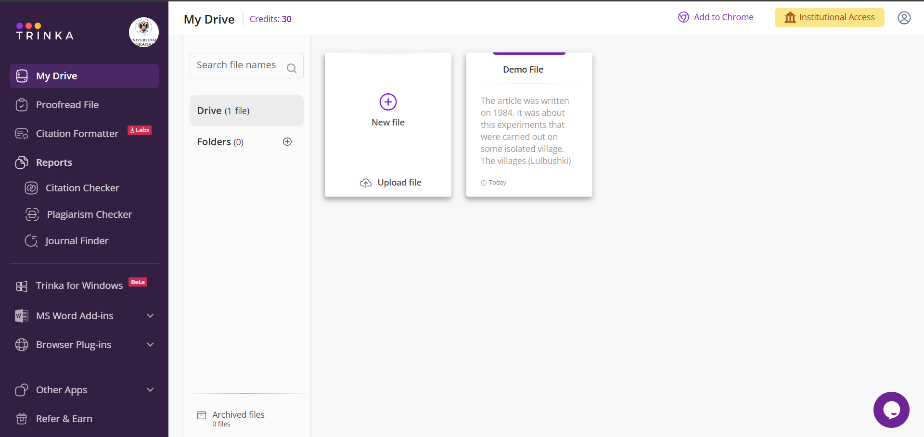
Figure 3: Trinka dashboard showing institutional access activation
Note: The university logo on the top left corner of your dashboard confirms that your Institutional Access subscription is active.

3. Core Features

3.1 Trinka Cloud Editor
Once you have registered on Trinka AI, you will be automatically signed in and can start using Trinka. If you have logged out, you can log in by visiting https://cloud.trinka.ai/signin and entering your email address and password. Once logged in, you will be on "My Drive." From this page, you can access all files you create or upload on Trinka.

3.1.1 Uploading a File
You can upload a file in .doc, .docx, or .txt format from your system, OneDrive, Dropbox, or Google Drive.
Step 1: Click on "Upload file"
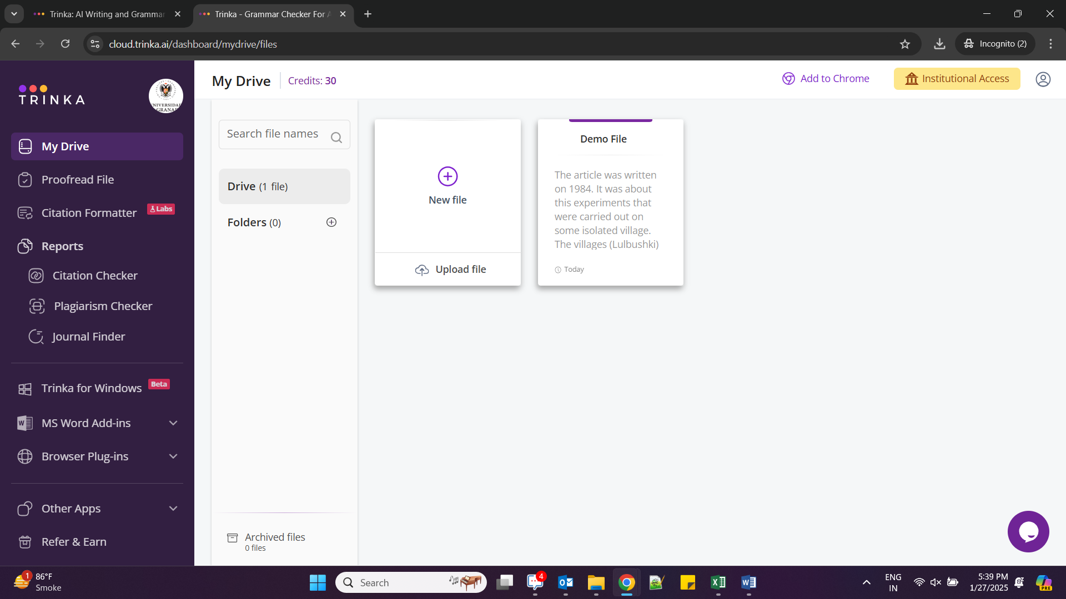
Figure 4: My Drive page with the Upload file option
Step 2: Select the upload source.
Click on any option and upload your file.
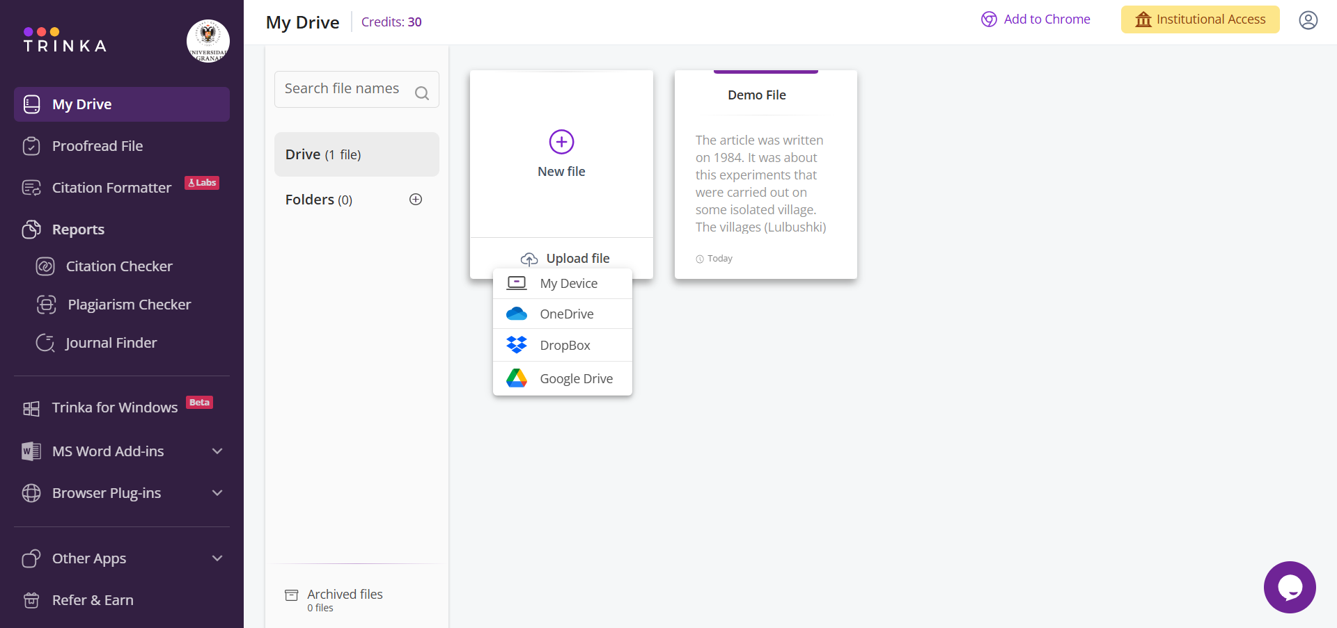
Figure 5: File Upload Source Options
Step 3: Set preferences
After a successful upload, select language preferences, document type, and style guides. Then click "Save" and proceed.
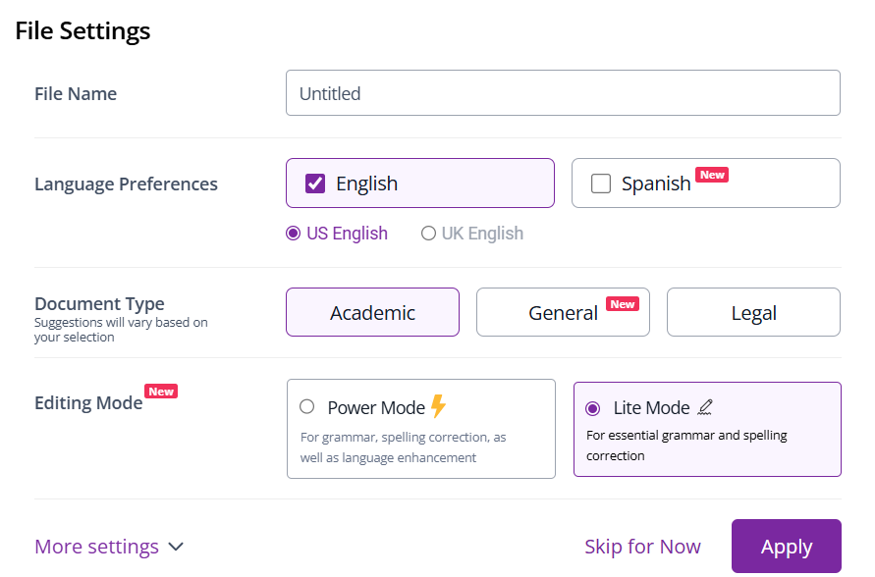
Figure 6: Language and Style Preferences Dialog

Step 4: The file opens in the editor.
Your file will open in the Trinka Cloud Editor for review.
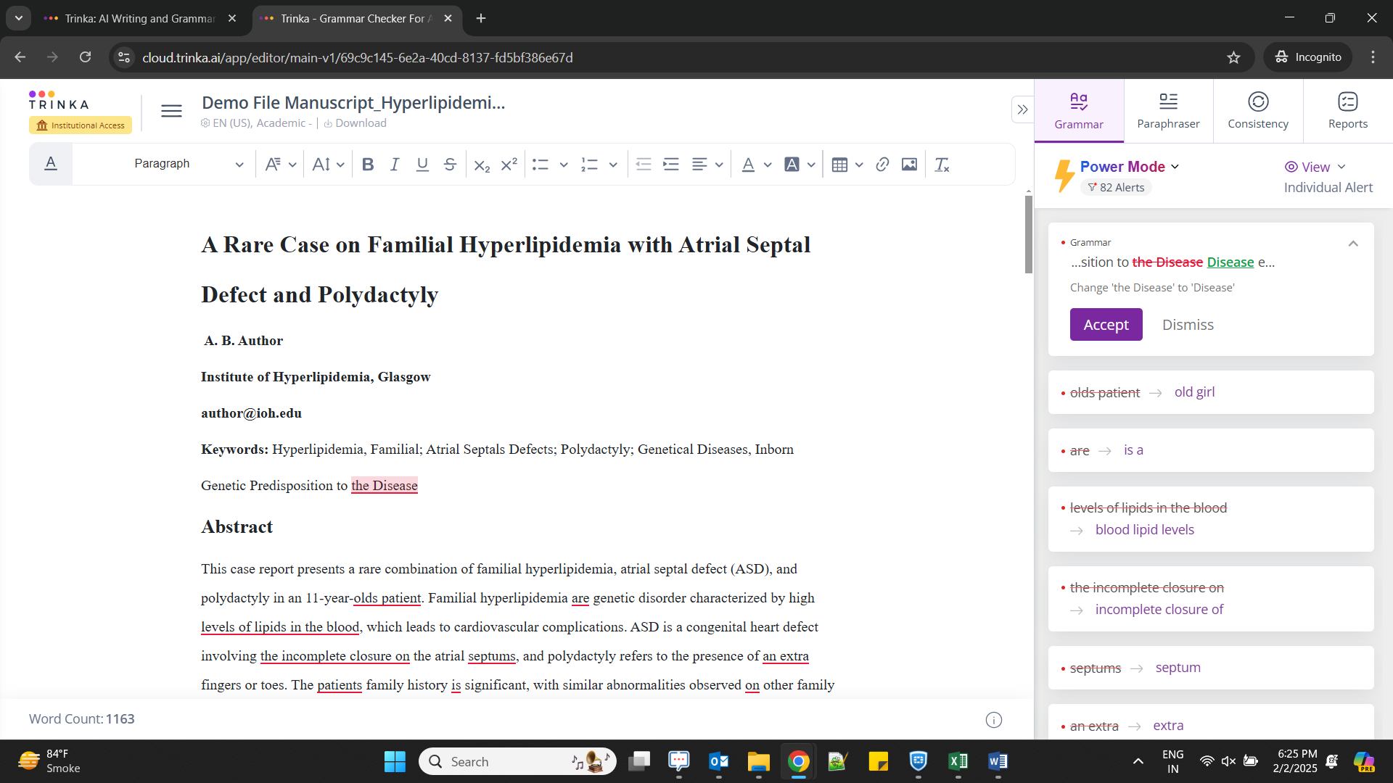
Figure 7: File opened in Trinka Cloud Editor

3.1.2 Creating a New File
Step 1: Create a new file
Click on the "+" icon above "New file" to create a new file.
Figure 8: My Drive page with the New File option
Step 2: Set preferences
Select your language preferences, document type, and style guides, then click "Save and proceed".
Figure 9: Preferences dialog for the new file

Step 3: Start writing.
A new blank file will open in the editor.
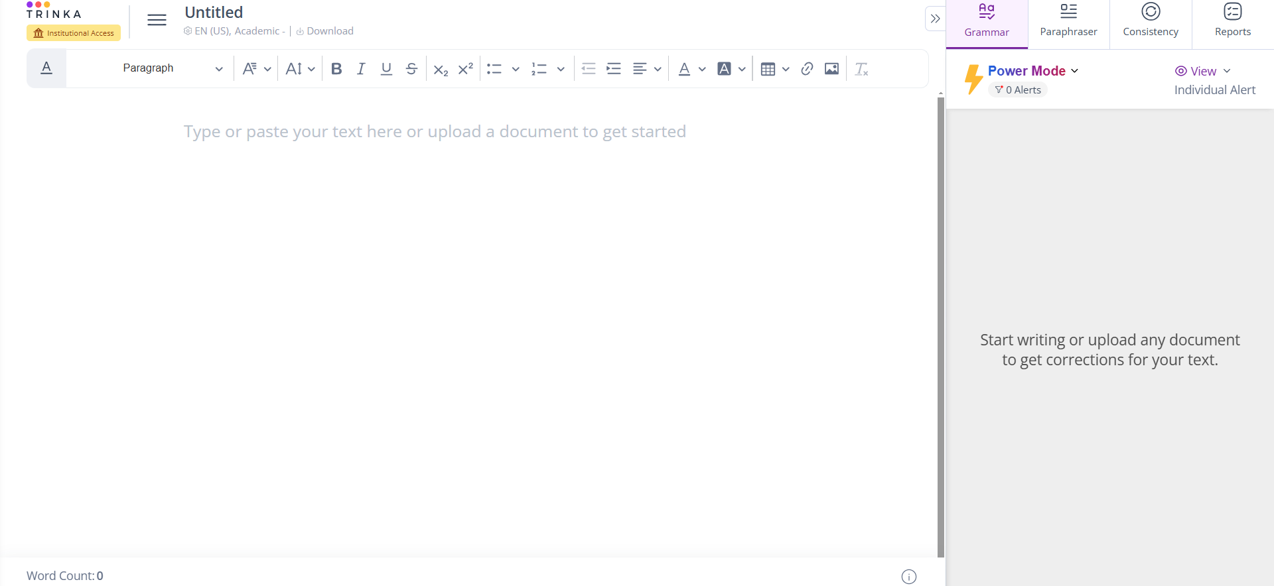
Figure 10: New blank file in Trinka Cloud Editor

3.2 Paraphraser
Trinka's Paraphraser helps you rephrase text while maintaining the original meaning, improving clarity and fluency.
Step 1: Open the Paraphraser.
After uploading your file, click on the "Paraphraser" option in the right panel.
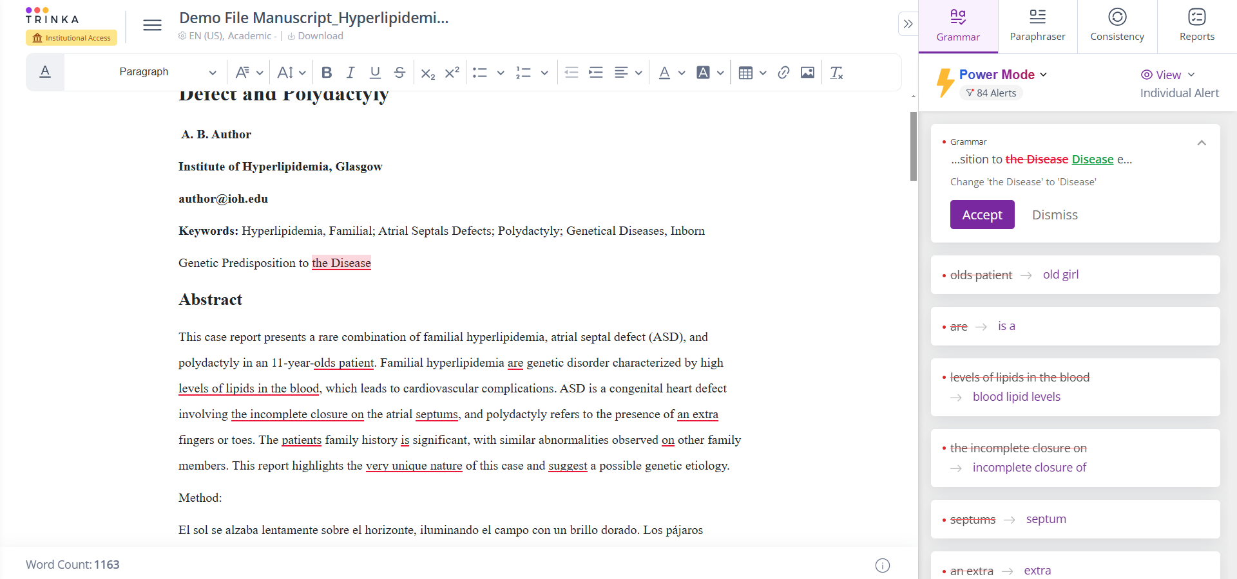
Figure 11: Paraphraser option on the right panel
Step 2: Select text and paraphrase.
Select text from your file and click the "Paraphrase" button.
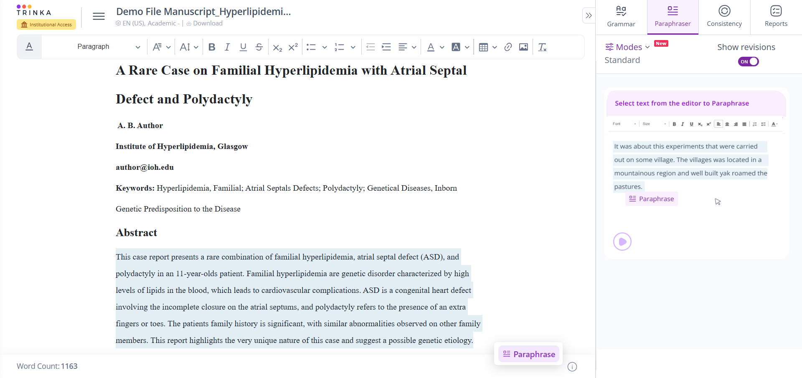
Figure 12: Selecting text for paraphrasing

Step 3: Review and replace
Review the paraphrased text on the right panel. Click "Replace" to substitute the original text. You can hide changes and set the degree of change from "Low" to "High."
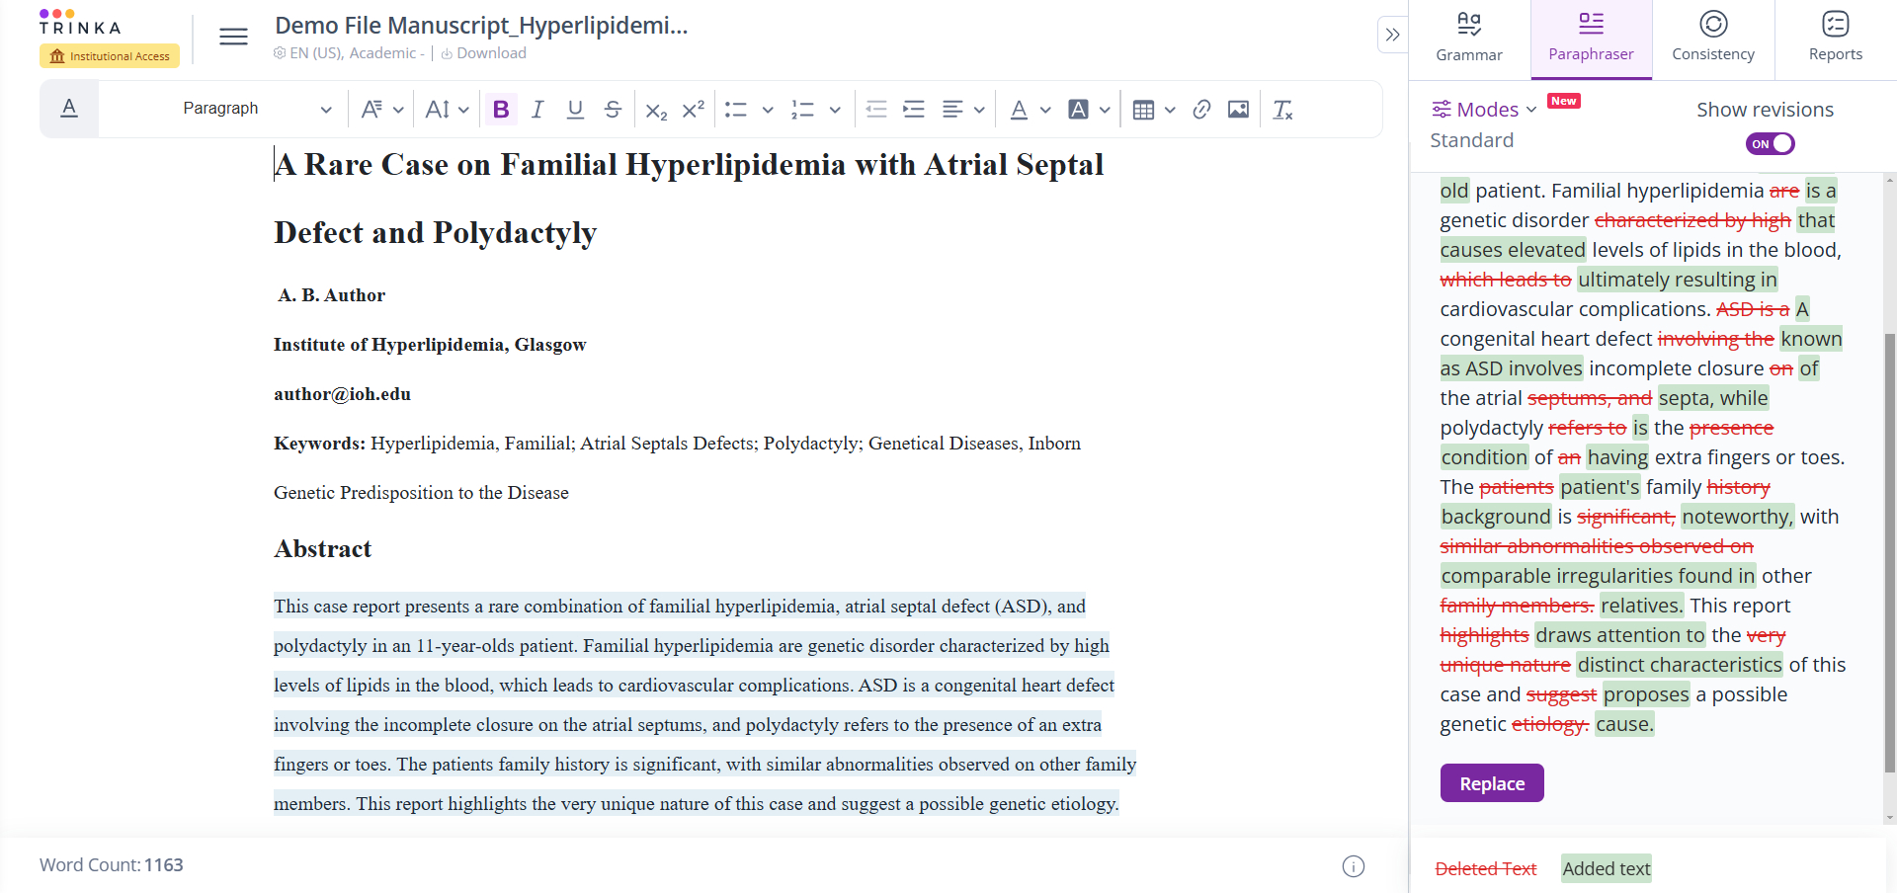
Figure 13: paraphrases Text with Replace Options
Step 4: Select the editing mode.
Choose the editing mode that best suits your needs.
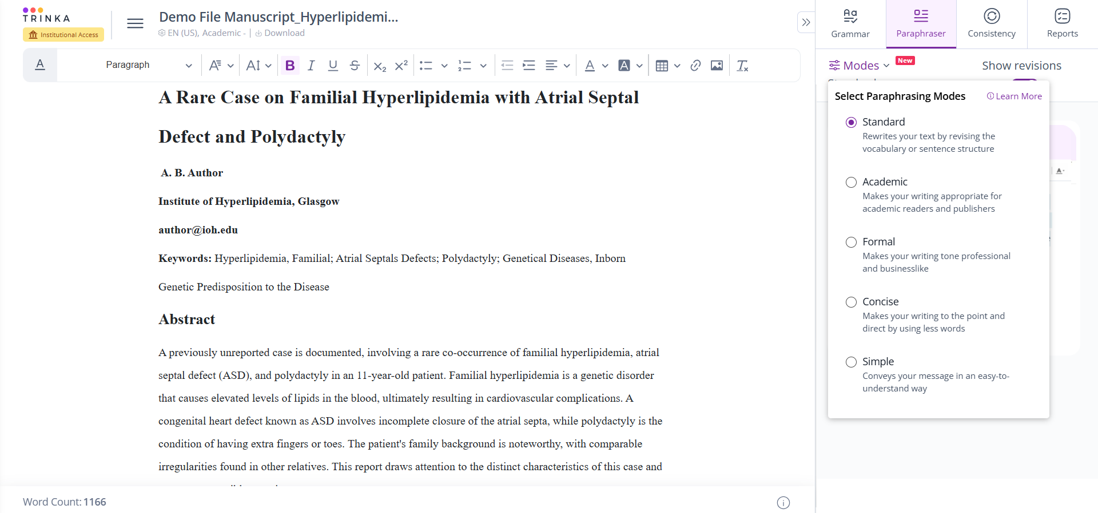
Figure 14: Editing Mode Selection for Paraphraser

3.3 Trinka AI Studio
Trinka AI Studio is a collection of AI-powered writing tools that help you generate, expand, and refine academic content directly inside the Trinka Cloud Editor. With AI Studio, you can quickly create outlines, paragraphs, summaries, and other academic texts while maintaining a formal tone and clarity.

3.3.1 AI-Assisted Writing Using /Ask
The /ask feature lets you use Trinka's AI-assisted writing to generate new content or continue your writing from within the editor. You can use it to draft sections of your paper, expand points, or improve flow based on the existing context in your document.
Step 1: Open a file.
Open a new file or existing document in Trinka Cloud Editor.
Figure 15: Opening a file in the Cloud Editor
Step 2: Place the cursor
Place the cursor where you want to generate or continue content.
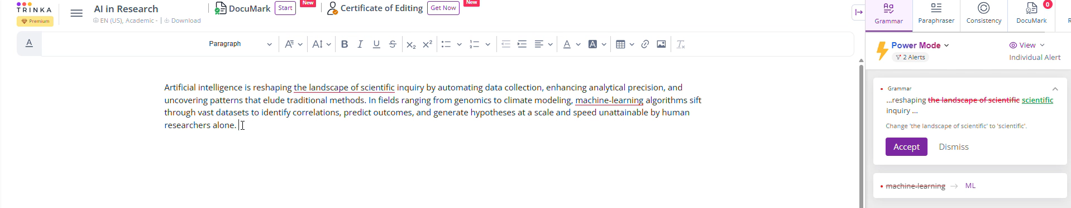
Figure 16: Cursor placement for content generation.

Step 3: Type/ask
Type /ask in the editor. A panel with AI options will appear.
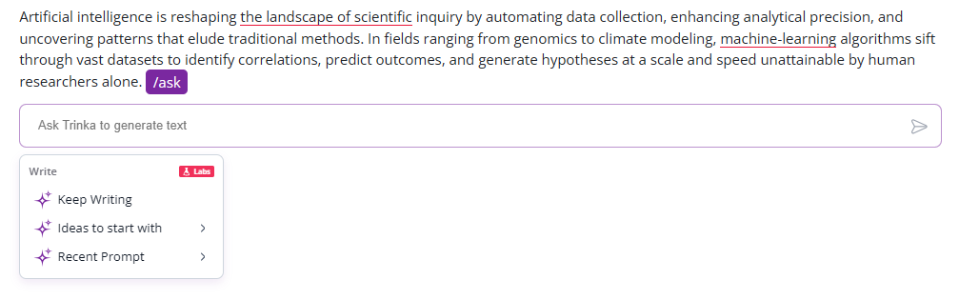
Figure 17: The /ask command panel
Step 4: Select or type a prompt.
Select a ready-made prompt (e.g., Write a paragraph, Keep writing, Create an outline, etc.) or type your own instructions.
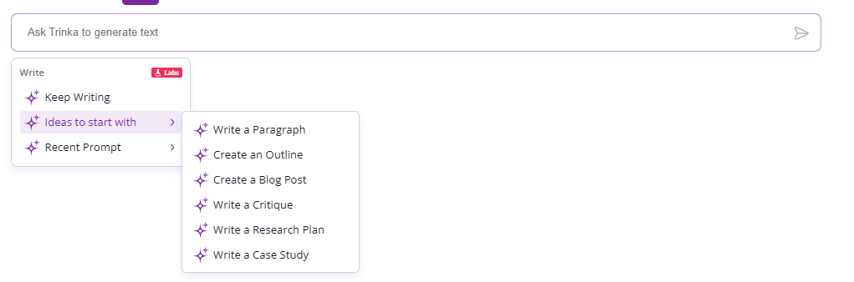
Figure 18: Prompt selection options.
Step 5: View the generated text
Click on a prompt or enter your custom prompt. The AI-generated text will appear in the editor.
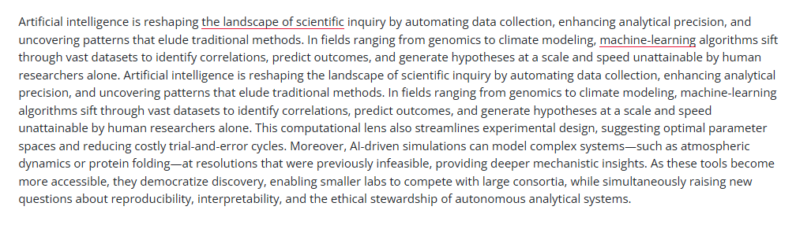
Figure 19: AI-generated text using the "Keep Writing" prompt

3.3.2 Using AI Prompts on Selected Text
You can select any part of your text and apply AI prompts to improve, transform, or translate it. This is useful when you already have a draft and want to make it clearer, more concise, more formal, or in another language.
Step 1: Select text.
Select the text in your document that you want to improve.
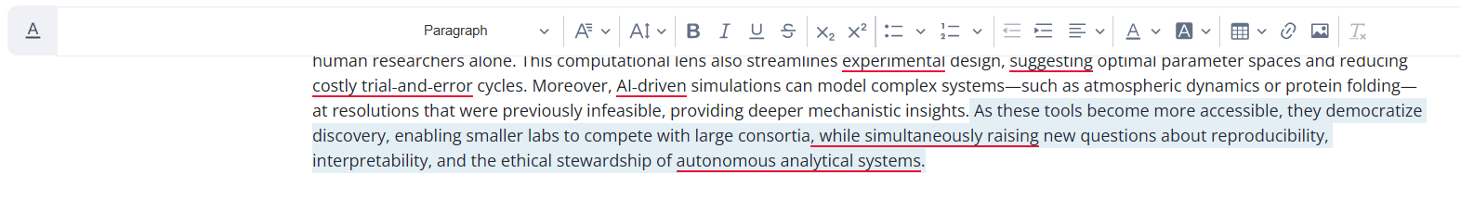
Figure 20: Selecting text for the AI prompt
Step 2: Click the AI icon.
Click the AI/assist icon (magic wand icon) that appears near the selection.
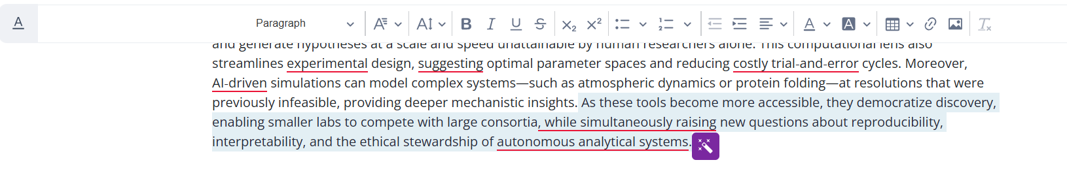
Figure 21: AI/assist icon near selected text
Step 3: Choose an option
Choose from options such as
- Improve fluency
- Improve clarity
- Make it Longer/Make it Shorter
- Adjust tone (e.g., more formal or neutral).
- Translate (e.g., to English or Spanish)
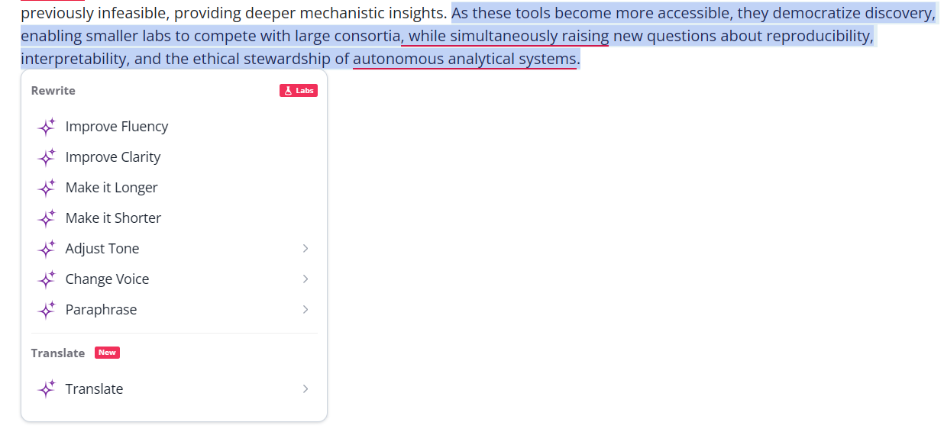
Figure 22: AI prompt options for selected text

Step 4: Review suggestions.
Trinka will show AI-suggested versions of your selected text.
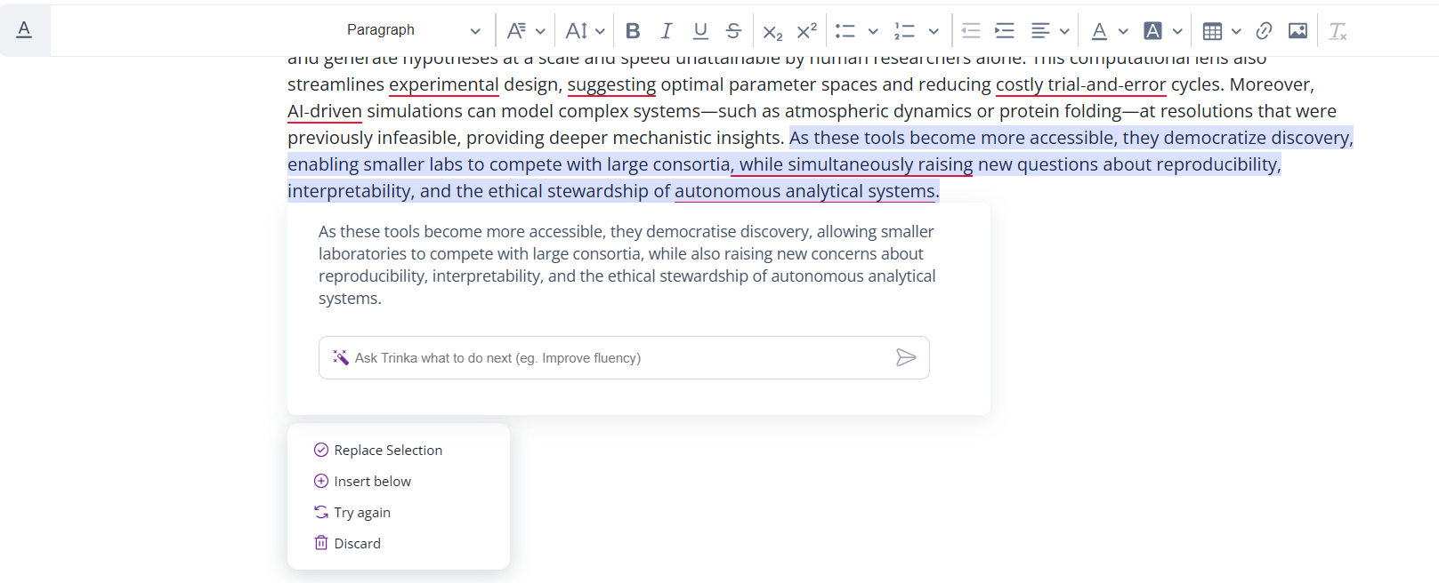
Figure 23: AI-Suggested Text Versions
Step 5: Apply changes
Click "Replace selection" or "Insert below" to apply the suggestion to your document.

3.3.3 Custom AI Tools for Educators and Students
Build secure, institution-specific AI writing tools without coding for everyday educator and student tasks.
For Educators:
- Create MCQs from lecture notes
- Generate press releases from manuscripts
- Create plain-language summaries from technical papers
For Students:
- Generate study notes from lecture transcripts
- Summarize research papers
- Draft cover letters from manuscripts
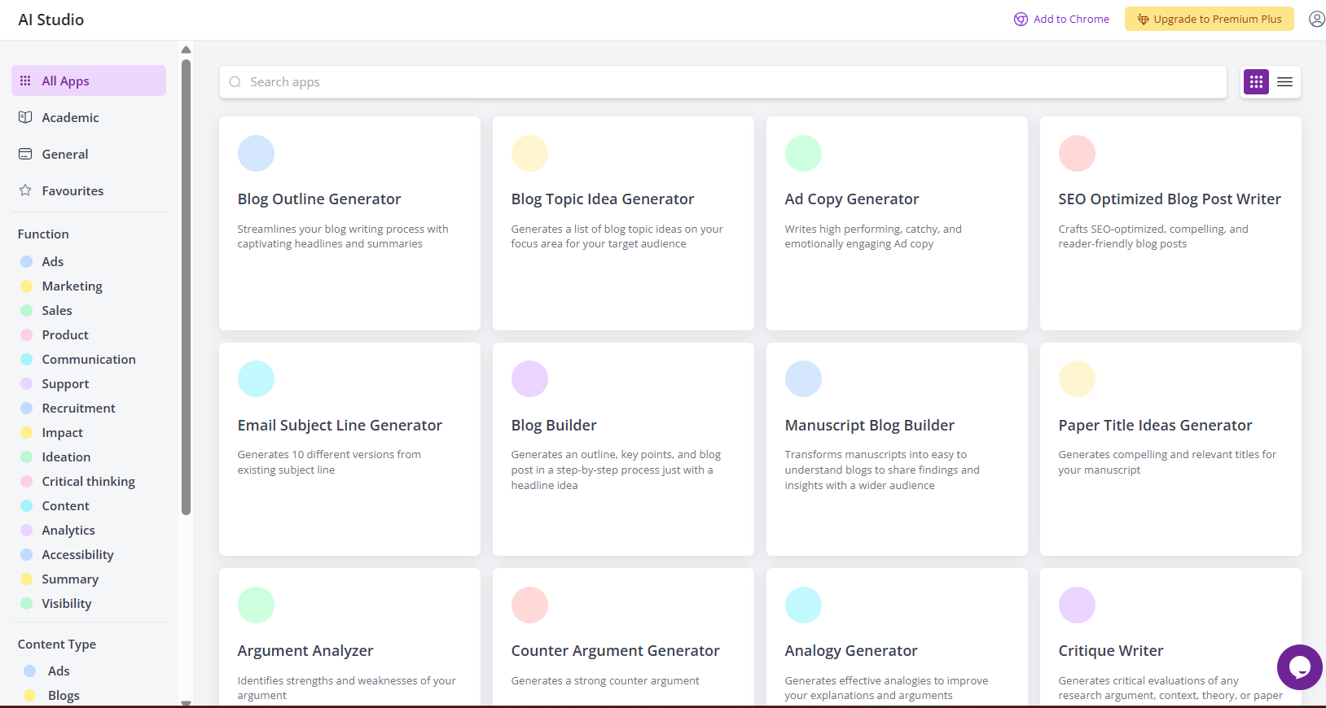
Figure 24: Custom AI tools interface for educators and students

3.4 Trinka Browser Plugins
Trinka AI is available as a plugin for popular browsers, including Google Chrome, Mozilla Firefox, and Microsoft Edge. Install the plugin for your preferred browser to receive Trinka's writing assistance across the web.
Step 1: Install your browser plugin.
Navigate to the Plugins page and click on the appropriate options for your browser.
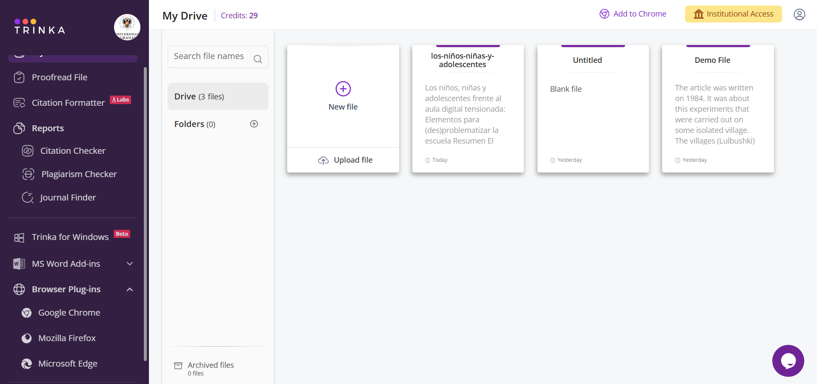
Figure 25: Browser plugin installation options.

4. Key Workflows

4.1 Editing with the Cloud Editor
Once your file opens in the Cloud Editor, Trinka AI will process your text and provide suggestions to improve the writing. Text with suggestions will be underlined, and suggestion cards will appear on the right panel. The default check mode is "Grammar."
Step 1: View suggestions
Expand a suggestion card on the right panel to view the details.
Figure 26: Suggestion Cards in the Editor's Right Panel
Step 2: Accept a suggestion
Click the "Accept" button to replace the text with the suggestion.
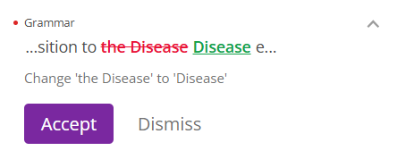
Figure 27: Accepting a grammar suggestion
Step 3: Dismiss a suggestion.
Click the "Dismiss" button to reject a suggestion. The original text will remain unchanged.
Step 4: Change Document Style
If necessary, change the "Document Style" using the respective options on the top menu.

Step 5: Change language or variant
You can change the language and language variant (US/UK) from the setting dialog.
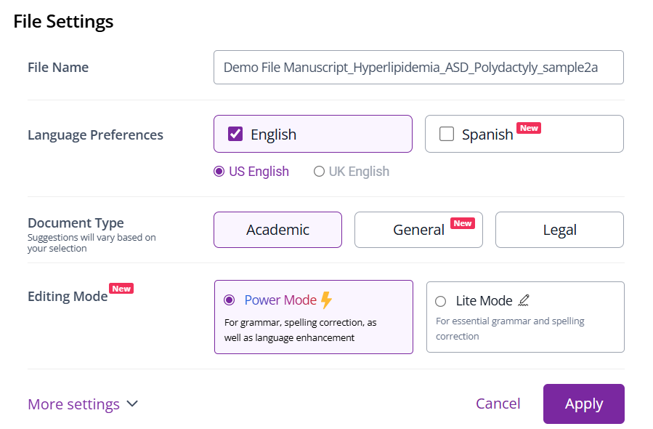
Figure 28: Language and Variant Selection Dialog
Step 6: Select the editing mode.
Choose the editing mode that best suits your needs.
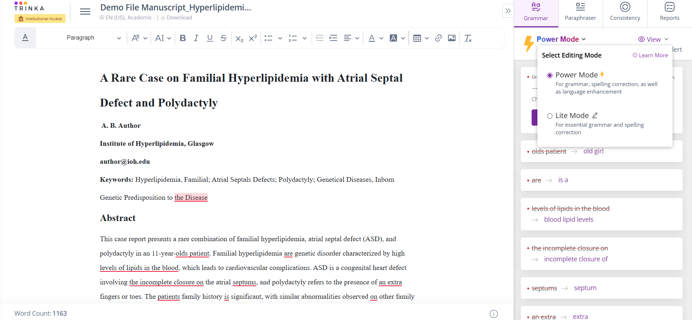
Figure 29: Editing mode selection.

Editing Mode Comparison
Mode | Description | When to Use
Power Mode | Corrects language and enhances it with advanced AI suggestions. Also paraphrases the text lightly for clarity and fluency. | When you need both corrections and enhancements, especially to make writing clearer, more fluent, and impactful.
Lite Mode | Focuses on correcting basic grammar, spelling, and punctuation mistakes. Keeps your writing accurate. | When basic grammar corrections are sufficient or you just want to proofread the content.

4.2 Proofreading a File
Trinka's AI-powered "Proofread File" feature lets you proofread your file in minutes and download an AI-edited document containing suggestions as track changes.
Step 1: Open the Proofread File.
Click on "Proofread file" in the left menu.
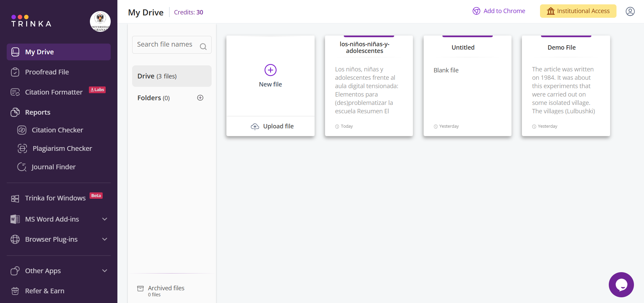
Figure 30: Proofread file option in the left menu
Step 2: Upload your file.
On the Proofread File page, click on "Trinka My drive", "My device", or "More" to upload your file.
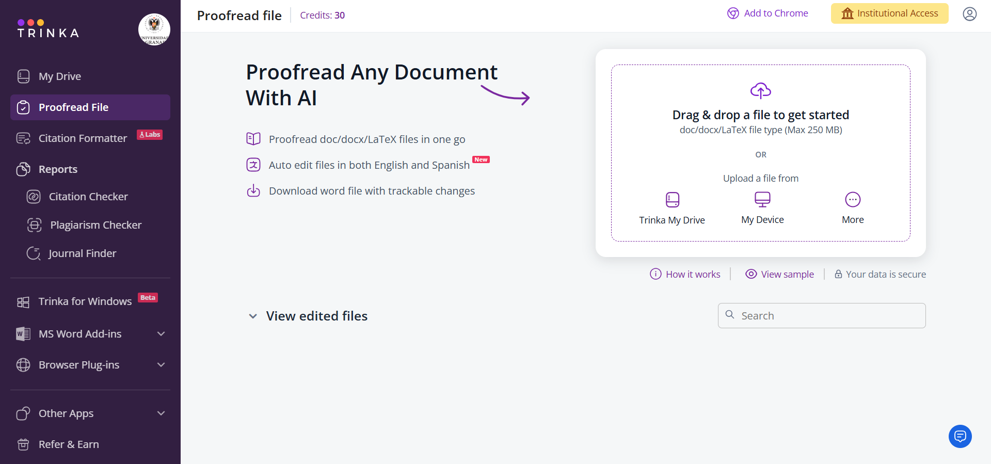
Figure 31: Proofread File Upload Options

Step 3: Set preferences and apply.
Configure language preferences and suggestion choices, then click "Apply."
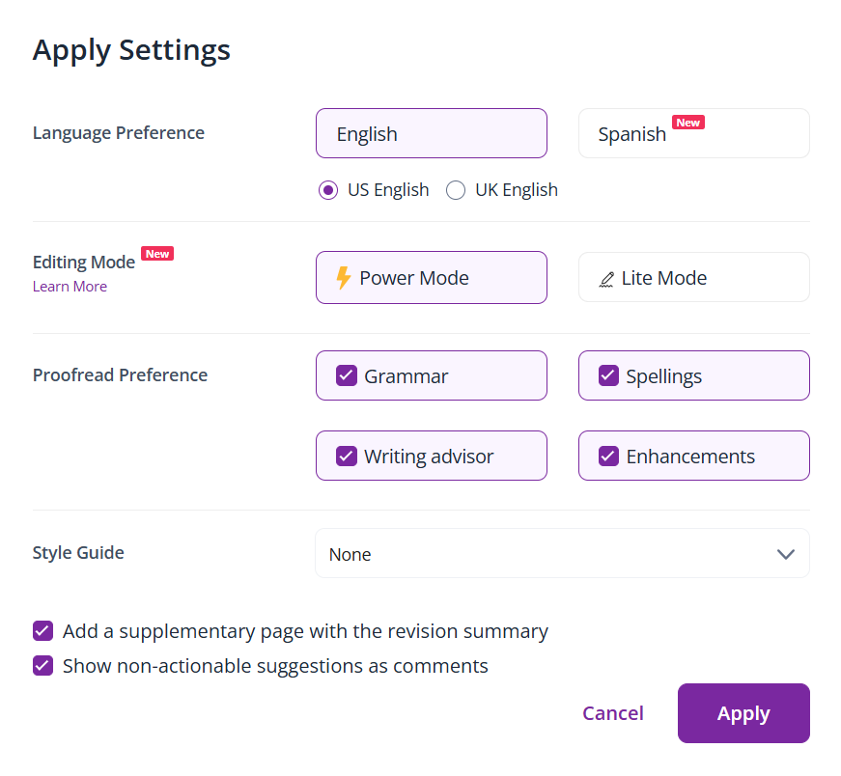
Figure 32: Proofread preferences dialog.
Step 4: Start Proofreading
After applying the settings, click "Start Proofreading" to begin processing.
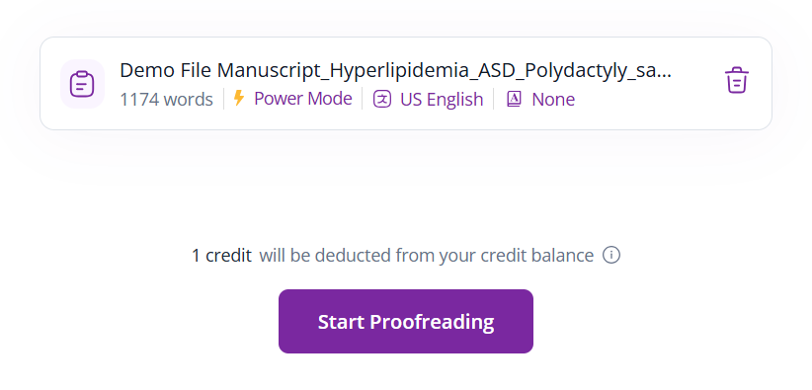
Figure 33: Start Proofreading button with saved settings

Step 5: Download the proofread file.
After processing completes, click "Download" to get a track-changed file with suggestions.
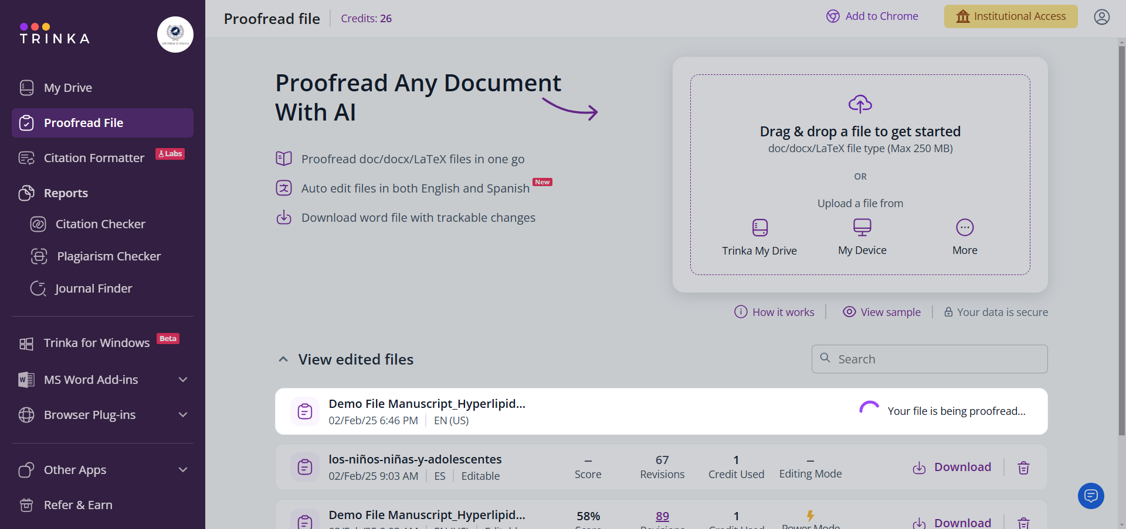
Figure 34: File being processed
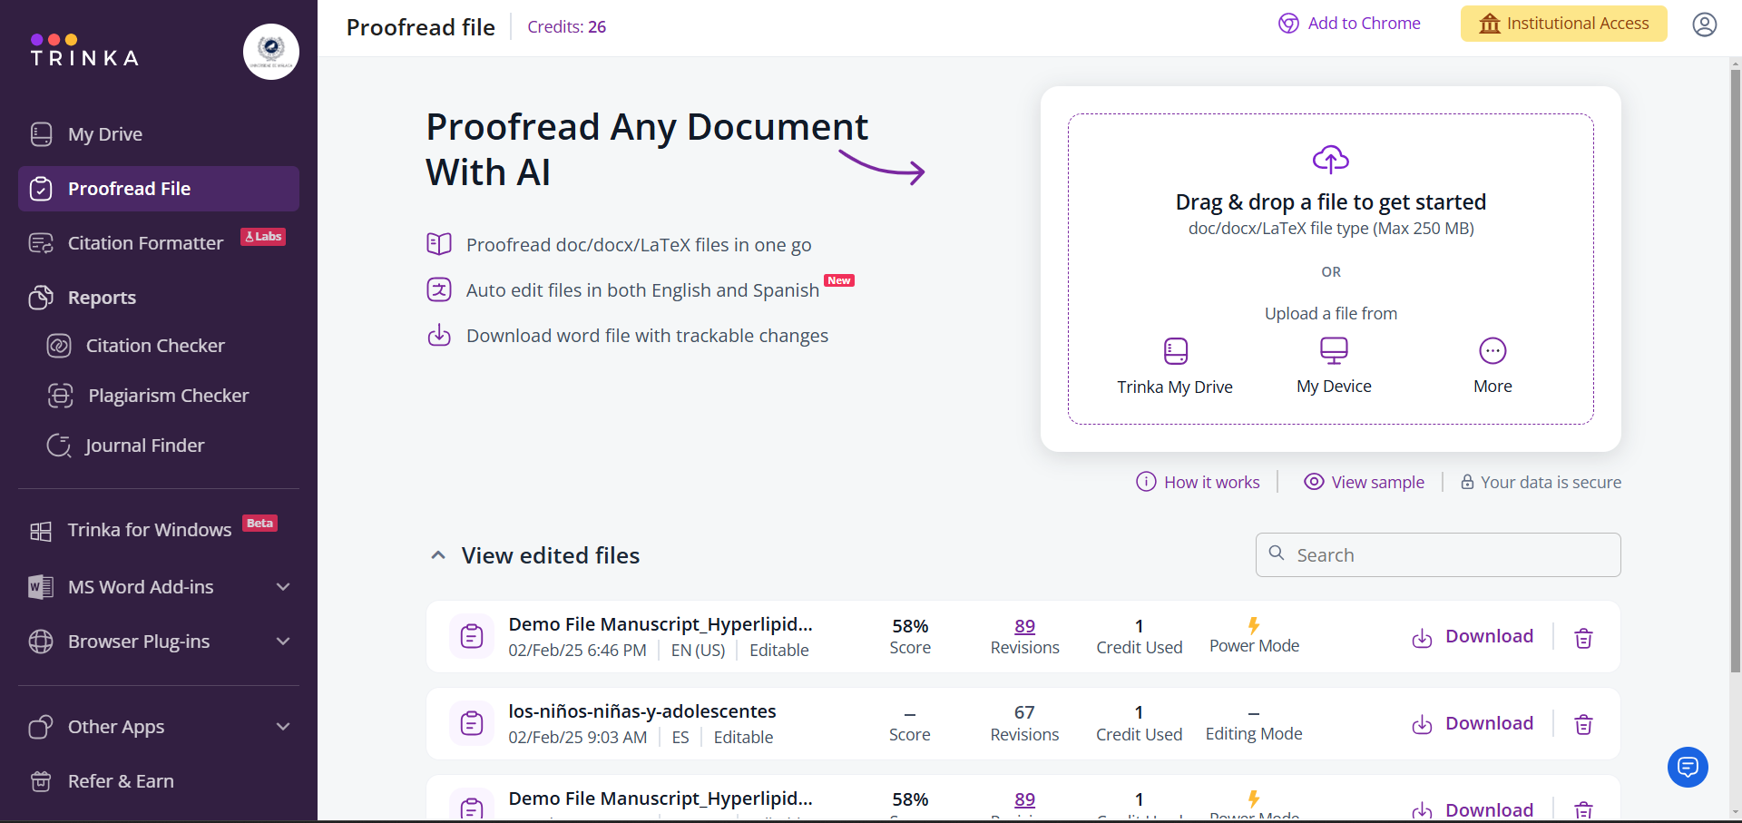
Figure 35: Download option after processing completes

Step 6: Review track changes.
The downloaded file will contain suggestions provided by Trinka AI, including track changes and comments.
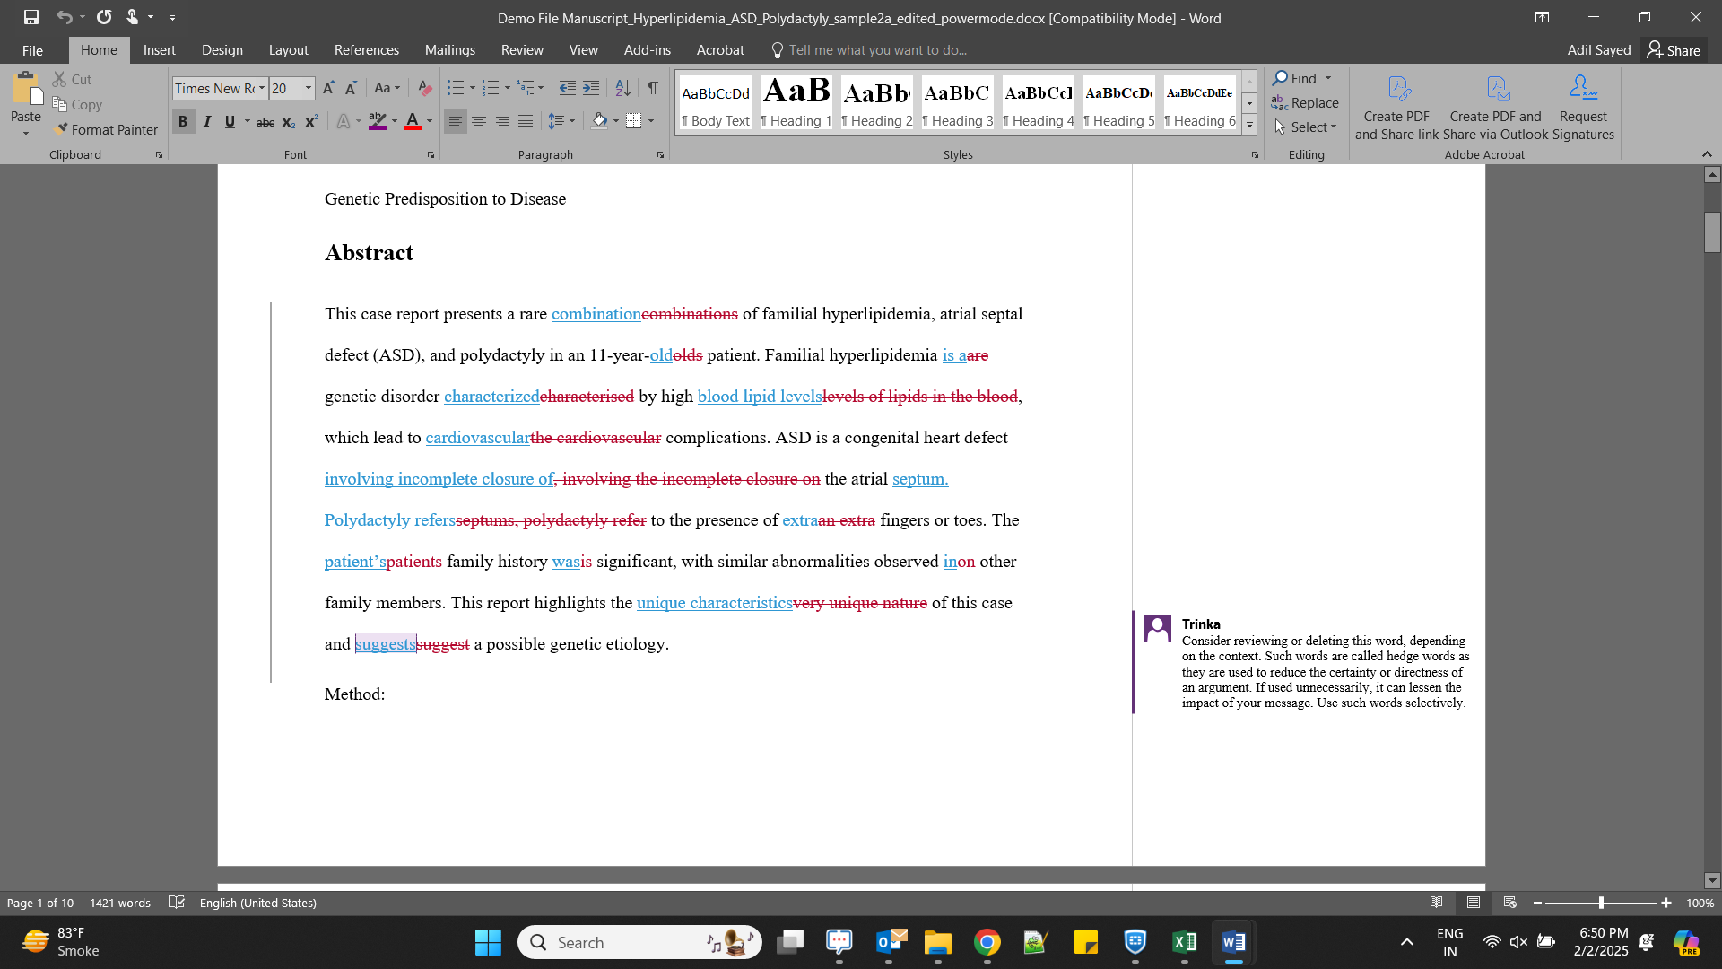
Figure 36: Downloaded file with track changes and comments

5. Verifying content authenticity

5.1 Generating AI Content Detector Reports
Trinka's AI Content Detector helps verify whether content was generated using AI tools. This feature produces detailed reports that can be used for academic integrity checks.
Step 1: Navigate to the AI Content Detector.
Go to the AI Content Detector report creation page:
https://cloud.trinka.ai/reports/#/dashboard/create-report?source=AI-CD
Step 2: Upload your document.
Upload a document in.doc,.docx, or.pdf format using the options provided.
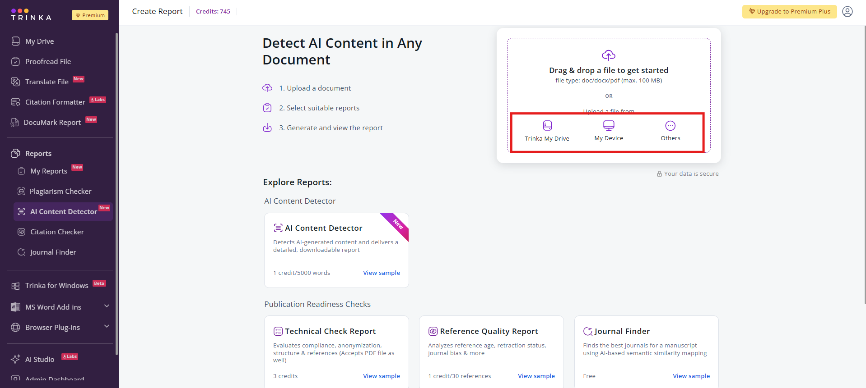
Figure 37: AI Content Detector File Upload Page
Step 3: Generate the report.
Select the "AI Content Detector Report Card" and click "Generate" to create the report.
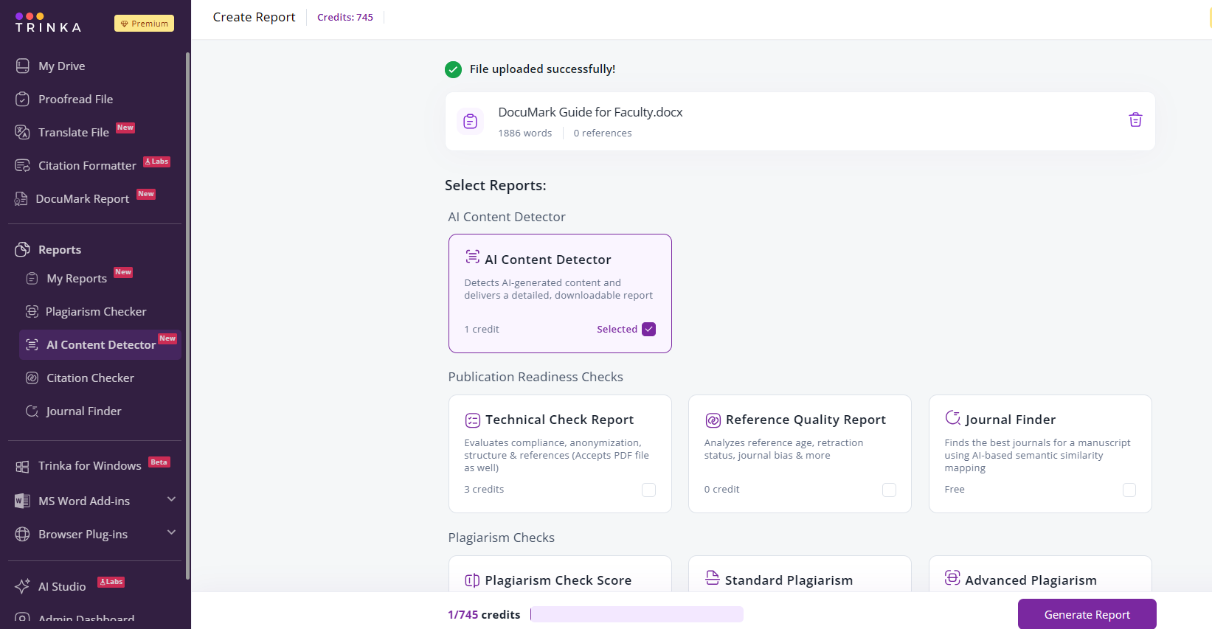
Figure 38: Report Generation with AI Content Detector Selection
Important: 1 credit will be deducted for every 5,000 words processed when generating AI Content Detector reports.

Step 4: Download the report.
The generated report can be downloaded from the "My Reports" section.
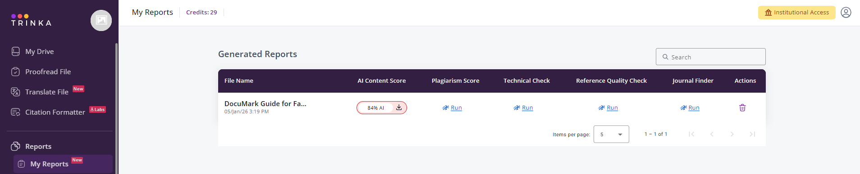
Figure 39: My Reports section with the download option

6. Additional Information

6.1 Language Support
Trinka AI supports the Spanish language with its Grammar Checker, Paraphrasing, and Proofreading features, in addition to English.

6.2 Related Platforms
You can use your Trinka credentials to access these additional platforms:
- Enago Read — https://www.read.enago.com/
- Enago Reports — https://www.reports.enago.com/

6.3 Feature Usage and Credit Consumption
Features | Credits Consumed
AI Content Detector Report  Identify AI generated texts produced by LLMs to preserve content integrity. | 1 credit for every 5000 words in a file
Proofread File  Automatically edit MS Word files in minutes and download a tracked changed file with all changes. | 1 credit for every 5000 words in a file
Technical Checks  Evaluates your document for publication readiness against 20+ checkpoints - Journal Selection, Ethical Compliance, and more. | 1 credit for every report
Citation Checker  Identify citations that can make your research argumentation weaker and cite credible, strong citations for your paper. | 1 credit for up to 30 citations
Citation Formatter  Format, validate, and standardise citations in for all major styles in seconds. | 1 credit for up to 30 citations

6.4 Resources
Resource | Link/Details
Trinka Website | https://www.trinka.ai/
Trinka Cloud Editor | https://cloud.trinka.ai/signin
Video Tutorials | https://www.youtube.com/playlist?list=PL9shMilLZcA9YwwQrkSHJnh9oTQtYQ1TP
Enago Read | https://www.read.enago.com/
Enago Reports | https://www.reports.enago.com/

6.5 Support and Feedback
In case of any technical, usage, or other difficulties, please approach the help desk for a solution.
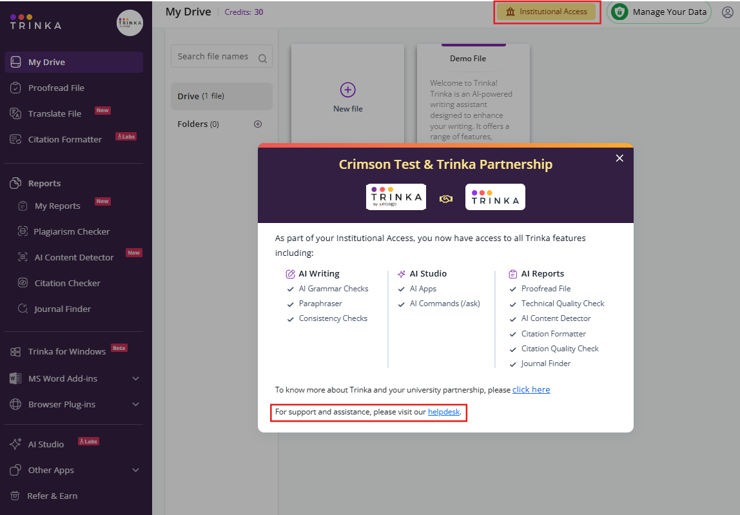
To find your helpdesk link, simply click on the Institutional Access button located in the top right corner of your Trinka homepage. A pop-up window will appear displaying all the features available to you through your institution. The helpdesk link will be visible at the bottom of this window, as shown in the screenshot above.
Thank You for Choosing Trinka AI.
Empowering Academic Excellence Through AI-Powered Writing Assistance

